**K-Nearest Neighbor**

**Load Data**

Loading the Iris dataset from scikit-learn. Here, the third column represents the petal length, and the fourth column the petal width of the flower samples. The classes are already converted to integer labels where 0=Iris-Setosa, 1=Iris-Versicolor, 2=Iris-Virginica.

import warnings

warnings.filterwarnings('ignore')

from matplotlib.colors import ListedColormap

import matplotlib.pyplot as plt

%matplotlib inline

from sklearn import datasets

import numpy as np

import pandas as pd

from sklearn import tree

from sklearn import metrics

iris = datasets.load_iris()

X = iris.data

y = iris.target

print('Class labels:', np.unique(y))

**Output:**

Class labels: [0 1 2]

**Normalize data:** the unit of measurement might differ so lets normalize the data before building the model.

from sklearn.preprocessing import StandardScaler

sc = StandardScaler()

sc.fit(X)

X = sc.transform(X)

**Split data into train and test**: Whenever we are using radom function its advised to use a seed to ensure the reproducibility of the results.

# split data into train and test

from sklearn.model_selection import train_test_split

X_train, X_test, y_train, y_test = train_test_split(X, y, test_size=0.3, random_state=0)

def plot_decision_regions(X, y, classifier):

h = .02 # step size in the mesh

# setup marker generator and color map

markers = ('s', 'x', 'o', '^', 'v')

colors = ('red', 'blue', 'lightgreen', 'gray', 'cyan')

cmap = ListedColormap(colors[:len(np.unique(y))])

# plot the decision surface

x1_min, x1_max = X[:, 0].min() - 1, X[:, 0].max() + 1

x2_min, x2_max = X[:, 1].min() - 1, X[:, 1].max() + 1

xx1, xx2 = np.meshgrid(np.arange(x1_min, x1_max, h),

np.arange(x2_min, x2_max, h))

Z = classifier.predict(np.array([xx1.ravel(), xx2.ravel()]).T)

Z = Z.reshape(xx1.shape)

plt.contourf(xx1, xx2, Z, alpha=0.4, cmap=cmap)

plt.xlim(xx1.min(), xx1.max())

plt.ylim(xx2.min(), xx2.max())

for idx, cl in enumerate(np.unique(y)):

plt.scatter(x=X[y == cl, 0], y=X[y == cl, 1],

alpha=0.8, c=cmap(idx),

marker=markers[idx], label=cl)

from sklearn.neighbors import KNeighborsClassifier

clf = KNeighborsClassifier(n_neighbors=5, p=2, metric='minkowski')

clf.fit(X_train, y_train)

# generate evaluation metrics

print("Train - Accuracy :", metrics.accuracy_score(y_train, clf.predict(X_train)))

print("Train - Confusion matrix :",metrics.confusion_matrix(y_train, clf.predict(X_train)))

print("Train - classification report :", metrics.classification_report(y_train, clf.predict(X_train)))

print("Test - Accuracy :", metrics.accuracy_score(y_test, clf.predict(X_test)))

print("Test - Confusion matrix :",metrics.confusion_matrix(y_test, clf.predict(X_test)))

print("Test - classification report :", metrics.classification_report(y_test, clf.predict(X_test)))

**Output:**

Train - Accuracy : 0.9714285714285714

Train - Confusion matrix : [[34 0 0]

[ 0 31 1]

[ 0 2 37]]

Train - classification report :

precision recall f1-score support

0 1.00 1.00 1.00 34

1 0.94 0.97 0.95 32

2 0.97 0.95 0.96 39

micro avg 0.97 0.97 0.97 105

macro avg 0.97 0.97 0.97 105

weighted avg 0.97 0.97 0.97 105

Test - Accuracy : 0.9777777777777777

Test - Confusion matrix : [[16 0 0]

[ 0 17 1]

[ 0 0 11]]

Test - classification report :

precision recall f1-score support

0 1.00 1.00 1.00 16

1 1.00 0.94 0.97 18

2 0.92 1.00 0.96 11

micro avg 0.98 0.98 0.98 45

macro avg 0.97 0.98 0.98 45

weighted avg 0.98 0.98 0.98 45

### Plot Decision Boundary

Let's consider a two class example to keep things simple.

**# Let's use sklearn make_classification function to create some test data.**

from sklearn.datasets import make_classification

X, y = make_classification(

# the usual parameters

n_samples=100, n_features=2, n_informative=2, n_redundant=0, n_classes=2,

# Set label 0 for 80% and 1 for rest 20% of observations

weights=[.8,.2],

)

# build a simple logistic regression model

clf = KNeighborsClassifier(n_neighbors=5, p=2, metric='minkowski')

clf.fit(X, y)

**Output:**

KNeighborsClassifier(algorithm='auto', leaf_size=30, metric='minkowski',

metric_params=None, n_jobs=None, n_neighbors=5, p=2,

weights='uniform')

**# Plot the decision boundary**

plot_decision_regions(X, y, classifier=clf)

plt.xlabel('X1')

plt.ylabel('X2')

plt.legend(loc='upper left')

plt.tight_layout()

plt.show()

**Output:**

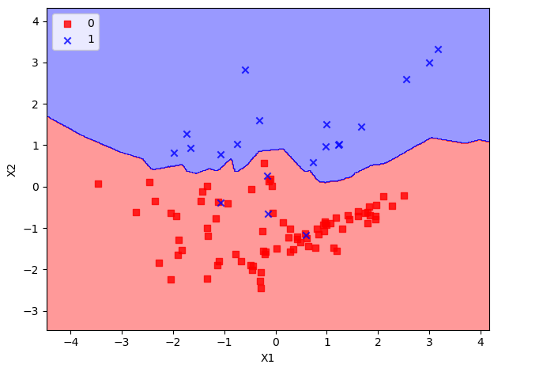

**K-means Clustering**

Let's use unsupervised learning i.e., clustering to find out how many species exists. The goal here is to group all similar items into a cluster.

import warnings

warnings.filterwarnings('ignore')

from matplotlib.colors import ListedColormap

import matplotlib.pyplot as plt

%matplotlib inline

from sklearn import datasets

import numpy as np

import pandas as pd

from sklearn.cluster import KMeans

from sklearn.metrics import silhouette_samples, silhouette_score

from sklearn import metrics

from sklearn.preprocessing import StandardScaler

iris = datasets.load_iris()

# Let's convert to dataframe

iris = pd.DataFrame(data= np.c_[iris['data'], iris['target']],

columns= iris['feature_names'] + ['species'])

# let's remove spaces from column name

iris.columns = iris.columns.str.replace(' ','')

iris.head()

X = iris.iloc[:,:3] # independent variables

y = iris.species # dependent variable

sc = StandardScaler()

sc.fit(X)

X = sc.transform(X)

# K Means Cluster

model = KMeans(n_clusters=3, random_state=11)

model.fit(X)

print(model.labels_)

**Output:**

[1 1 1 1 1 1 1 1 1 1 1 1 1 1 1 1 1 1 1 1 1 1 1 1 1 1 1 1 1 1 1 1 1 1 1 1 1

1 1 1 1 0 1 1 1 1 1 1 1 1 2 2 2 0 2 0 2 0 2 0 0 0 0 0 0 2 0 0 0 0 2 0 0 0

2 2 2 2 0 0 0 0 0 0 0 2 2 0 0 0 0 2 0 0 0 0 0 0 0 0 2 0 2 2 2 2 0 2 2 2 2

2 2 0 0 2 2 2 2 0 2 0 2 0 2 2 0 2 2 2 2 2 2 2 0 2 2 2 0 2 2 2 0 2 2 2 0 2

2 0]

##**CONFUSION MATRIX Generation**

# since its unsupervised the labels have been assigned

# not in line with the actual lables so let's convert all the 1s to 0s and 0s #to 1s

# 2's look fine

iris['pred_species'] = np.choose(model.labels_, [1, 0, 2]).astype(np.int64)

print("Accuracy :", metrics.accuracy_score(iris.species, iris.pred_species))

print("Classification report :", metrics.classification_report(iris.species, iris.pred_species))

**Output:**

Accuracy : 0.8066666666666666

Classification report :

precision recall f1-score support

0.0 1.00 0.98 0.99 50

1.0 0.71 0.70 0.71 50

2.0 0.71 0.74 0.73 50

micro avg 0.81 0.81 0.81 150

macro avg 0.81 0.81 0.81 150

weighted avg 0.81 0.81 0.81 150

**##PLOTTING:**

# Set the size of the plot

plt.figure(figsize=(10,7))

# Create a colormap for red, green and blue

cmap = ListedColormap(['r', 'g', 'b'])

# Plot Sepal

plt.subplot(2, 2, 1)

plt.scatter(iris['sepallength(cm)'], iris['sepalwidth(cm)'], c=cmap(iris.species), marker='o', s=50)

plt.xlabel('sepallength(cm)')

plt.ylabel('sepalwidth(cm)')

plt.title('Sepal (Actual)')

plt.subplot(2, 2, 2)

plt.scatter(iris['sepallength(cm)'], iris['sepalwidth(cm)'], c=cmap(iris.pred_species), marker='o', s=50)

plt.xlabel('sepallength(cm)')

plt.ylabel('sepalwidth(cm)')

plt.title('Sepal (Predicted)')

plt.subplot(2, 2, 3)

plt.scatter(iris['petallength(cm)'], iris['petalwidth(cm)'], c=cmap(iris.species),marker='o', s=50)

plt.xlabel('petallength(cm)')

plt.ylabel('petalwidth(cm)')

plt.title('Petal (Actual)')

plt.subplot(2, 2, 4)

plt.scatter(iris['petallength(cm)'], iris['petalwidth(cm)'], c=cmap(iris.pred_species),marker='o', s=50)

plt.xlabel('petallength(cm)')

plt.ylabel('petalwidth(cm)')

plt.title('Petal (Predicted)')

plt.tight_layout()

**Output:**

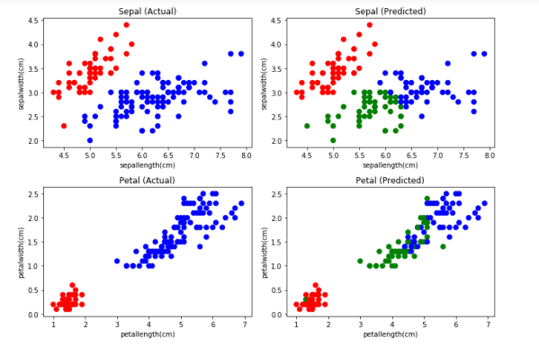

### Finding value of K:

### from scipy.spatial.distance import cdist, pdist

### from sklearn.cluster import KMeans

### K = range(1,10)

### KM = [KMeans(n_clusters=k).fit(X) for k in K]

### centroids = [k.cluster_centers_ for k in KM]

### D_k = [cdist(X, cent, 'euclidean') for cent in centroids]

### cIdx = [np.argmin(D,axis=1) for D in D_k]

### dist = [np.min(D,axis=1) for D in D_k]

### avgWithinSS = [sum(d)/X.shape[0] for d in dist]

### # Total with-in sum of square

### wcss = [sum(d**2) for d in dist]

### tss = sum(pdist(X)**2)/X.shape[0]

### bss = tss-wcss

### varExplained = bss/tss*100

### kIdx = 10-1

### ##### plot ###

### kIdx = 2

### # elbow curve

### # Set the size of the plot

### plt.figure(figsize=(10,4))

### plt.subplot(1, 2, 1)

### plt.plot(K, avgWithinSS, 'b*-')

### plt.plot(K[kIdx], avgWithinSS[kIdx], marker='o', markersize=12,

### markeredgewidth=2, markeredgecolor='r', markerfacecolor='None')

### plt.grid(True)

### plt.xlabel('Number of clusters')

### plt.ylabel('Average within-cluster sum of squares')

### plt.title('Elbow for KMeans clustering')

### plt.subplot(1, 2, 2)

### plt.plot(K, varExplained, 'b*-')

### plt.plot(K[kIdx], varExplained[kIdx], marker='o', markersize=12,

### markeredgewidth=2, markeredgecolor='r', markerfacecolor='None')

### plt.grid(True)

### plt.xlabel('Number of clusters')

### plt.ylabel('Percentage of variance explained')

### plt.title('Elbow for KMeans clustering')

### plt.tight_layout()

**Output:**

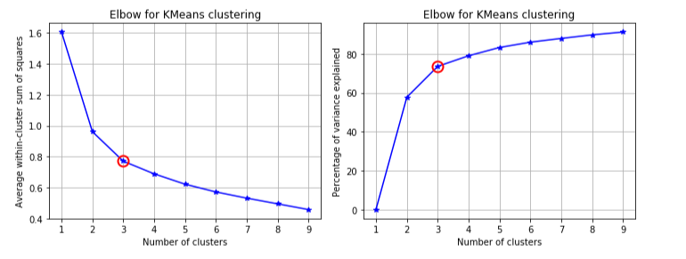

**Average silhouette method**

from sklearn.metrics import silhouette_score

from matplotlib import cm

score = []

for n_clusters in range(2,10):

kmeans = KMeans(n_clusters=n_clusters)

kmeans.fit(X)

labels = kmeans.labels_

centroids = kmeans.cluster_centers_

score.append(silhouette_score(X, labels, metric='euclidean'))

# Set the size of the plot

plt.figure(figsize=(10,4))

plt.subplot(1, 2, 1)

plt.plot(score)

plt.grid(True)

plt.ylabel("Silouette Score")

plt.xlabel("k")

plt.title("Silouette for K-means")

# Initialize the clusterer with n_clusters value and a random generator

model = KMeans(n_clusters=3, init='k-means++', n_init=10, random_state=0)

model.fit_predict(X)

cluster_labels = np.unique(model.labels_)

n_clusters = cluster_labels.shape[0]

# Compute the silhouette scores for each sample

silhouette_vals = silhouette_samples(X, model.labels_)

plt.subplot(1, 2, 2)

# Get spectral values for colormap.

cmap = cm.get_cmap("Spectral")

y_lower, y_upper = 0,0

yticks = []

for i, c in enumerate(cluster_labels):

c_silhouette_vals = silhouette_vals[cluster_labels]

c_silhouette_vals.sort()

y_upper += len(c_silhouette_vals)

color = cmap(float(i) / n_clusters)

plt.barh(range(y_lower, y_upper), c_silhouette_vals, facecolor=color, edgecolor=color, alpha=0.7)

yticks.append((y_lower + y_upper) / 2)

y_lower += len(c_silhouette_vals)

silhouette_avg = np.mean(silhouette_vals)

plt.yticks(yticks, cluster_labels+1)

# The vertical line for average silhouette score of all the values

plt.axvline(x=silhouette_avg, color="red", linestyle="--")

plt.ylabel('Cluster')

plt.xlabel('Silhouette coefficient')

plt.title("Silouette for K-means")

plt.show()

**Output:**

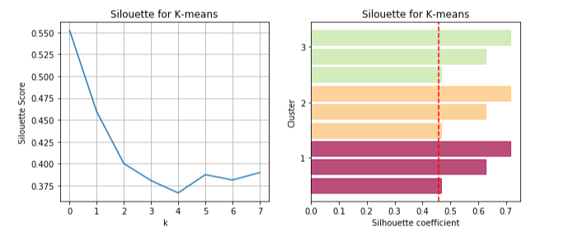

**Hierarchical Clustering**

from sklearn.cluster import AgglomerativeClustering

# Agglomerative Cluster

model = AgglomerativeClustering(n_clusters=3)

model.fit(X)

print(model.labels_)

iris['pred_species'] = model.labels_

print("Accuracy :", metrics.accuracy_score(iris.species, iris.pred_species))

print("Classification report :", metrics.classification_report(iris.species, iris.pred_species))

**Output:**

[0 0 0 0 0 0 0 0 0 0 0 0 0 0 0 0 0 0 0 0 0 0 0 0 0 0 0 0 0 0 0 0 0 0 0 0 0

0 0 0 0 1 0 0 0 0 0 0 0 0 2 2 2 1 2 1 2 1 2 1 1 1 1 1 1 2 1 1 1 1 2 1 1 1

1 2 2 2 1 1 1 1 1 1 1 2 2 1 1 1 1 1 1 1 1 1 1 1 1 1 2 1 2 1 2 2 1 2 1 2 2

1 2 1 1 2 2 2 2 1 2 1 2 1 2 2 1 1 1 2 2 2 1 1 1 2 2 2 1 2 2 2 1 2 2 2 1 2

2 1]

Accuracy : 0.7733333333333333

Classification report :

precision recall f1-score support

0.0 1.00 0.98 0.99 50

1.0 0.64 0.74 0.69 50

2.0 0.70 0.60 0.65 50

micro avg 0.77 0.77 0.77 150

macro avg 0.78 0.77 0.77 150

weighted avg 0.78 0.77 0.77 150

**PLOTTING ACTUAL Vs. PREDICTED**

# Set the size of the plot

plt.figure(figsize=(10,7))

# Create a colormap for red, green and blue

cmap = ListedColormap(['r', 'g', 'b'])

# Plot Sepal

plt.subplot(2, 2, 1)

plt.scatter(iris['sepallength(cm)'], iris['sepalwidth(cm)'], c=cmap(iris.species), marker='o', s=50)

plt.xlabel('sepallength(cm)')

plt.ylabel('sepalwidth(cm)')

plt.title('Sepal (Actual)')

plt.subplot(2, 2, 2)

plt.scatter(iris['sepallength(cm)'], iris['sepalwidth(cm)'], c=cmap(iris.pred_species), marker='o', s=50)

plt.xlabel('sepallength(cm)')

plt.ylabel('sepalwidth(cm)')

plt.title('Sepal (Predicted)')

plt.subplot(2, 2, 3)

plt.scatter(iris['petallength(cm)'], iris['petalwidth(cm)'], c=cmap(iris.species),marker='o', s=50)

plt.xlabel('petallength(cm)')

plt.ylabel('petalwidth(cm)')

plt.title('Petal (Actual)')

plt.subplot(2, 2, 4)

plt.scatter(iris['petallength(cm)'], iris['petalwidth(cm)'], c=cmap(iris.pred_species),marker='o', s=50)

plt.xlabel('petallength(cm)')

plt.ylabel('petalwidth(cm)')

plt.title('Petal (Predicted)')

plt.tight_layout()

**Output:**

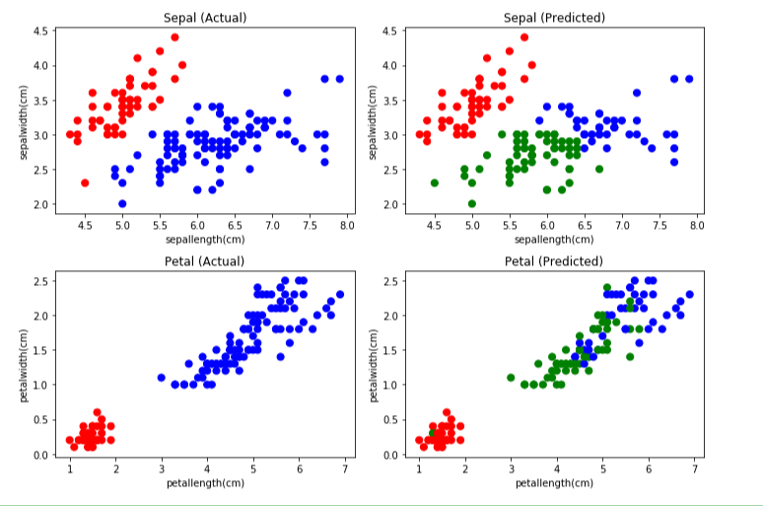

**AGGLOMERATIVE HIERARCHICAL CLUSTERING**

from scipy.cluster.hierarchy import cophenet, dendrogram, linkage

from scipy.spatial.distance import pdist

# generate the linkage matrix

Z = linkage(X, 'ward')

c, coph_dists = cophenet(Z, pdist(X))

# calculate full dendrogram

plt.figure(figsize=(25, 10))

plt.title('Agglomerative Hierarchical Clustering Dendrogram')

plt.xlabel('sample index')

plt.ylabel('distance')

dendrogram(

Z,

leaf_rotation=90., # rotates the x axis labels

leaf_font_size=8., # font size for the x axis labels

)

plt.tight_layout()

**Output:**

